STRUCTURAL ANALYSIS
By – Mehak Verma
Workflow :
- CAD Model Creation
- Designed a pulley model on Onshape CAD software with 5 grooves to represent the belt-contact geometry.
- The pulley was modelled with a central cylindrical hole for mounting/shaft support.
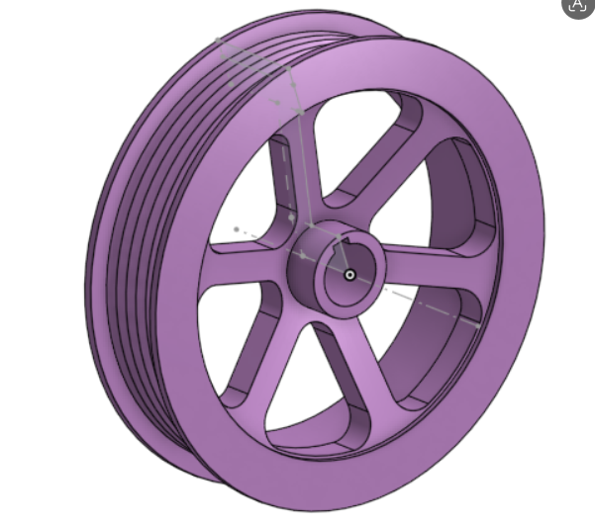

- Model Setup & Boundary Conditions
- Imported the pulley geometry in Altair Inspire for structural analysis ( .step model)
- Applied support to the inner cylindrical surface at the centre of the pulley to prevent rigid-body motion and restrict the degrees of freedom and represent the shaft constraint. (ie Displacement = 0)

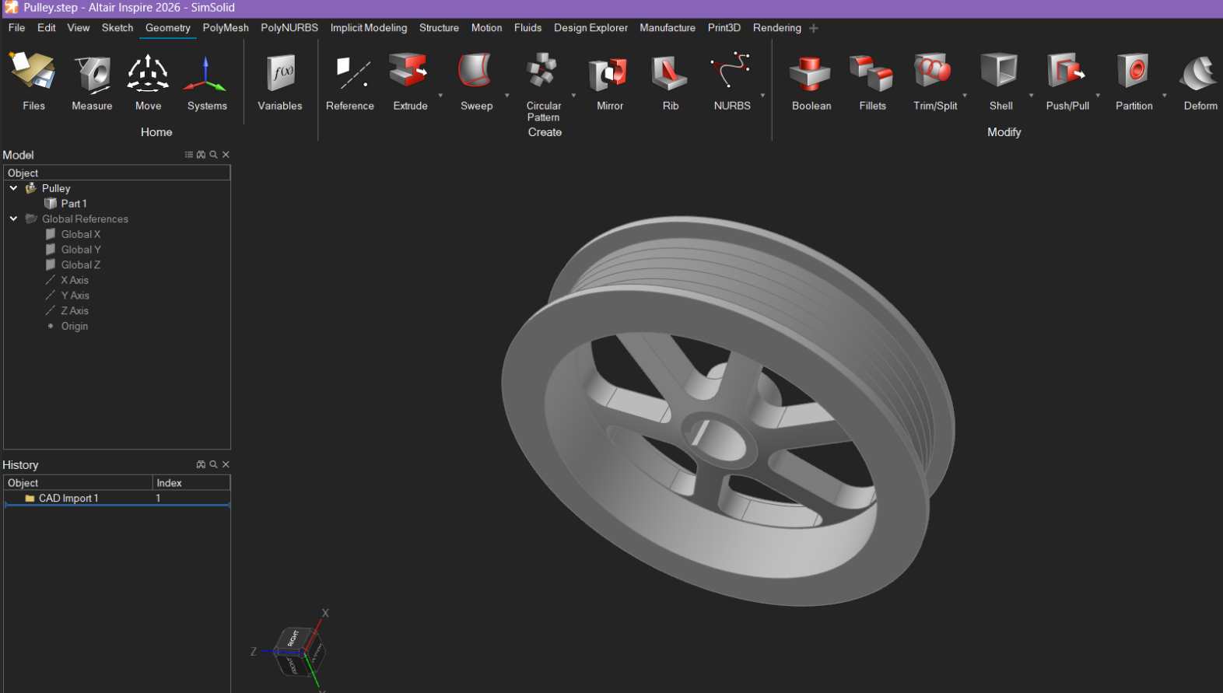
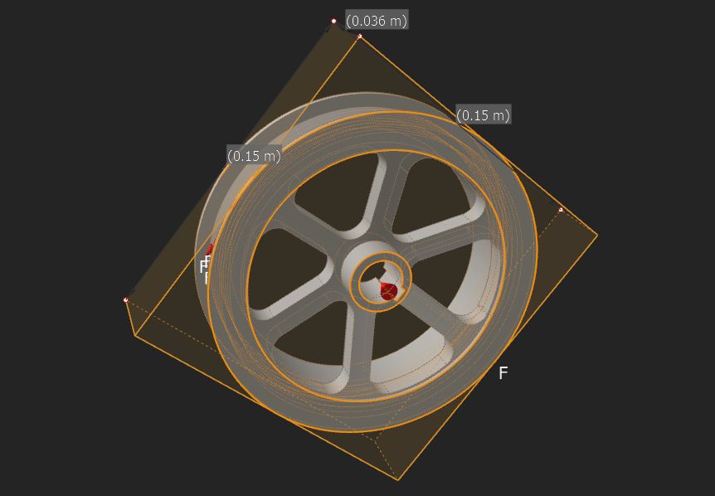
- Application of Belt Forces
- Applied a 200 N tangential force on each groove-contact face.
- The forces were applied tangentially to represent the load transmitted by the belt through the pulley grooves.

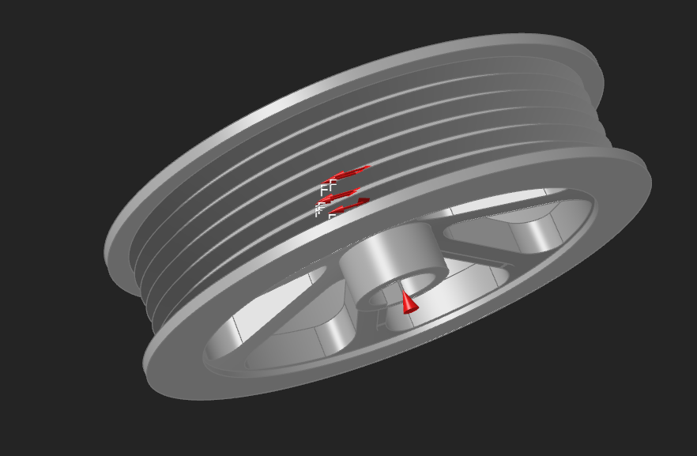

- Structural Analysis
- Performed a linear structural analysis to determine the pulley’s response under the applied loading and constraints.
- Evaluated the resulting:
  - Total deformation/displacement
  - Tension and compression
  - Von Mises stress

Results :
- Total Displacement
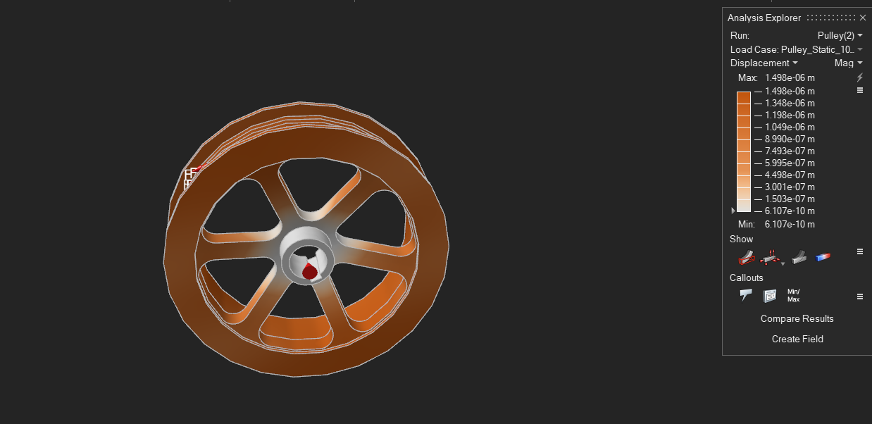

- The maximum total displacement is approximately 1.498 × 10⁻⁶ m (1.50 μm), indicating very small overall movement of the pulley under the applied loading.
- The displacement is concentrated mainly around the loaded outer/groove region, while the central supported region shows minimal displacement.
- The small magnitude of displacement indicates that the pulley maintains its overall structural shape under the applied 200 N tangential forces.

- Deformation
- The deformation plot shows that the pulley undergoes limited deformation, with the highest deformation occurring toward the outer regions subjected to the applied belt forces.
- The central region remains relatively constrained due to the applied support at the inner cylindrical surface.
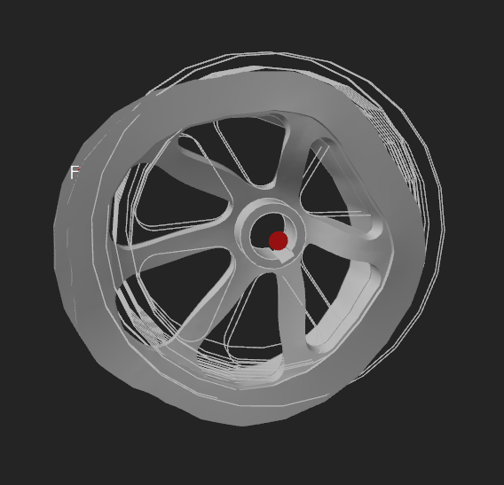

- Tension and compression
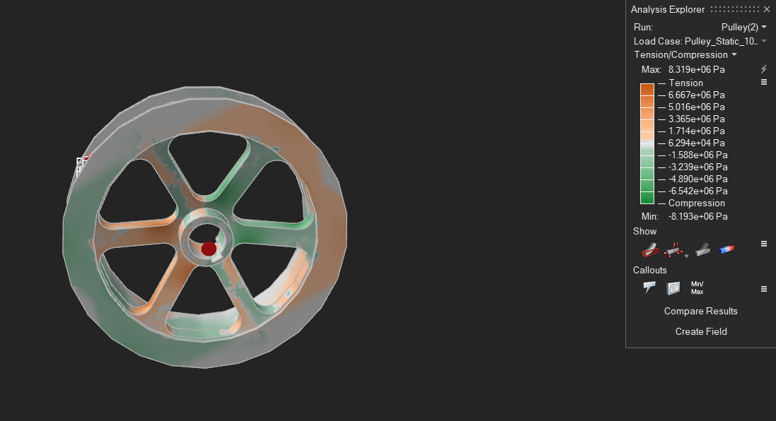
- The maximum tensile stress is approximately 8.319 MPa, while the maximum compressive stress is approximately 8.193 MPa.
- Tensile and compressive regions are distributed across the rim, spokes, and central hub, showing how the applied tangential forces are transferred through the pulley structure.
- The relatively similar magnitudes of tension and compression indicate a balanced stress response under the applied loading condition.

- Von-Misses Stress
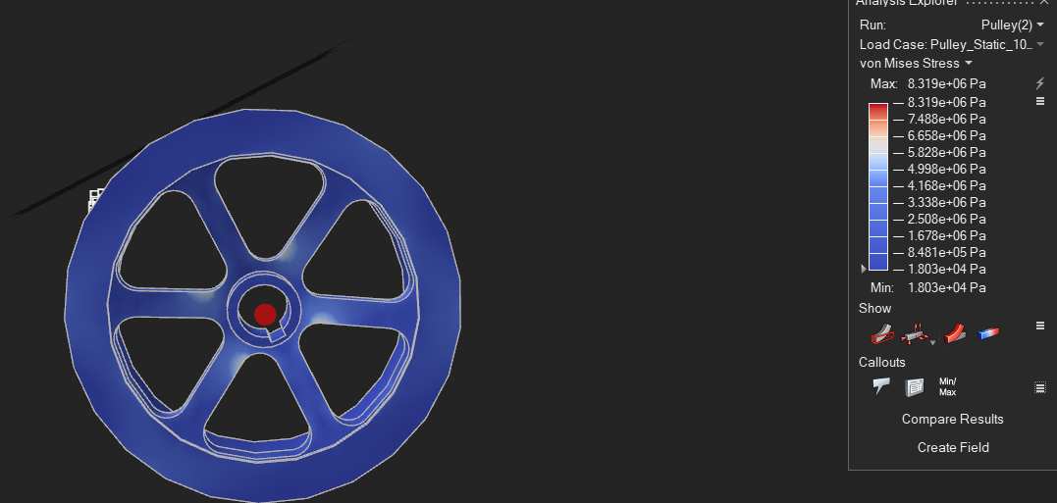

- The maximum Von Mises stress obtained is approximately 8.319 MPa, with the highest values concentrated around the central hub/spoke transition and other geometric regions where stresses are concentrated.
- Most of the pulley remains in the lower-stress range, as indicated by the predominantly blue regions in the contour plot.
- The stress distribution shows that the pulley experiences localized stress concentration rather than widespread high stress under the applied loading condition.

